CITY College
University of York Europe Campus

Computer Science Department

NAO as a Service Robot: An Intelligent Assistive Humanoid for Elderly Home Care
This report is submitted in partial fulfilment of the requirement for the degree of
Bachelor of Science with Honours in Computer Science by
Ada Urbina Merino
June 2026
NAO as a Service Robot: An Intelligent Assistive Humanoid for Elderly Home Care

by
Ada Urbina Merino

Supervisor: Dr Dimopoulos

ABSTRACT
This dissertation investigates whether generative artificial intelligence can be combined with assistive robotics to produce a system genuinely useful to elderly people living at home. Motivated by an ageing population and a widening gap between the demand for care and the carers available to provide it, the project designs and builds an intelligent assistive humanoid on the NAO platform within the Webots simulator. The system unites natural spoken conversation with practical assistance: it recognises and remembers its user, holds open-ended dialogue, issues medication reminders, offers companionship, and escorts the user between rooms after confirming where they are. Its guiding principle is a strict separation of concerns, a probabilistic language model is confined to interpreting language and conversing, while deterministic logic governs all movement and safety-critical action. Indoor navigation reasons over named rooms through a hierarchical planner and crosses doorways under explicit, inspectable control. Evaluation in simulation shows that the conversational and assistive behaviours succeed well, while physical navigation, doorway crossing above all, proves the hardest to make reliable and is the main source of failure. The work demonstrates a workable pattern for safe, conversational domestic assistance, and identifies perception, manipulation, and real-world hardware testing as the key steps toward deployment.

ACKNOWLEDGMENTS

DECLARATION

All sentences or passages quoted in this dissertation from other people’s work have been specifically acknowledged by clear cross-referencing to author, work and page(s). I understand that failure to do this, amounts to plagiarism and will be considered grounds for failure in this dissertation and the degree examination as a whole.
I have completed and submitted this work by myself without assistance from or communication with another person, either external or fellow student, or any AI type of content generator. I understand that not working on my own will be considered grounds for unfair means and will result in a fail mark for this work and might invoke disciplinary actions.

□ I agree that my dissertation can be used as a model/example by future students, for educational purposes only.

Name (block capitals): ............................................................................................................

Signed: ............................................................................. Date: ..............................................

Chapter 1 — Problem Description and Motivation 6
Chapter 2 — Background Research 9
2.1 The Global Ageing Population 9
2.2 Challenges Faced by Elderly People 10
2.3 Assistive Robotics 11
2.4 Human-Robot Interaction 12
2.5 Artificial Intelligence and Large Language Models 12
2.6 Indoor Navigation and Assistive Autonomy 13
2.7 Existing Assistive Robotic Systems and Related Work 14
2.8 Research Gap and Motivation for This Project 15
Chapter 3 — Project Vision and Planning 16
3.1 Vision of the Project 17
3.2 An AI-Centred Design Philosophy 17
3.3 The Choice of Webots and NAO 18
3.4 The Real Software Architecture 19
3.5 The AI Integration Strategy 20
3.6 Navigation and Assistive Planning Philosophy 21
3.7 Development Methodology and Iterative Planning 22
3.8 Project Planning and Implementation Stages 22
3.9 Critical Analysis of the Architectural Decisions 23
Chapter 4 — Project Implementation 23
4.1 Introduction to the Implementation 23
4.2 Overall System Implementation 24
4.3 Conversational AI Implementation 24
4.4 Voice Interaction and Communication Systems 25
4.5 Navigation System Implementation 26
4.6 Assistive Task Implementation 27
4.7 Environment Interaction 28
4.8 Iterative Development Process 28
4.9 Testing and Debugging 29
4.10 Requirement Analysis and Implementation Evaluation 29
4.11 Critical Technical Analysis 30
Chapter 5 — Evaluation and Critical Reflection 31
5.1 Introduction to the Evaluation 31
5.2 Evaluation of the Original Objectives 31
5.3 Evaluation of the AI Systems 32
5.4 Evaluation of Navigation and Assistive Behaviour 32
5.5 Evaluation of the Architecture and Implementation 33
5.6 Testing and Iterative Improvement Analysis 34
5.7 Limitations of the Current System 34
5.8 Societal and Ethical Reflection 35
5.9 Personal and Technical Reflection 35
Chapter 6 — Conclusion and Future Work 36
6.1 Overall Project Summary 36
6.2 Summary of Achievements 36
6.3 Contribution of the Project 36
6.4 Critical Reflection 37
6.5 Societal Impact and Future Relevance 37
6.6 Future Work 37
6.7 Concluding Reflection 39
References 41

Chapter 1 — Problem Description and Motivation
The phenomenon of world wide ageing has transformed a characteristic feature of humanity into a significant modern social issue. Extended life span combined with falling fertility rates in both developing and developed areas is causing an unprecedented rise in the proportion of seniors among the world's population, something for which our current system of elderly care is ill-equipped to handle [1], [2]. This chapter outlines the issue that will become the focus of the dissertation research: the issues faced by elderly people with reduced mobility or cognitive impairment in completing tasks at home. It will be shown throughout this dissertation that the use of intelligent robots is a feasible solution to this issue.
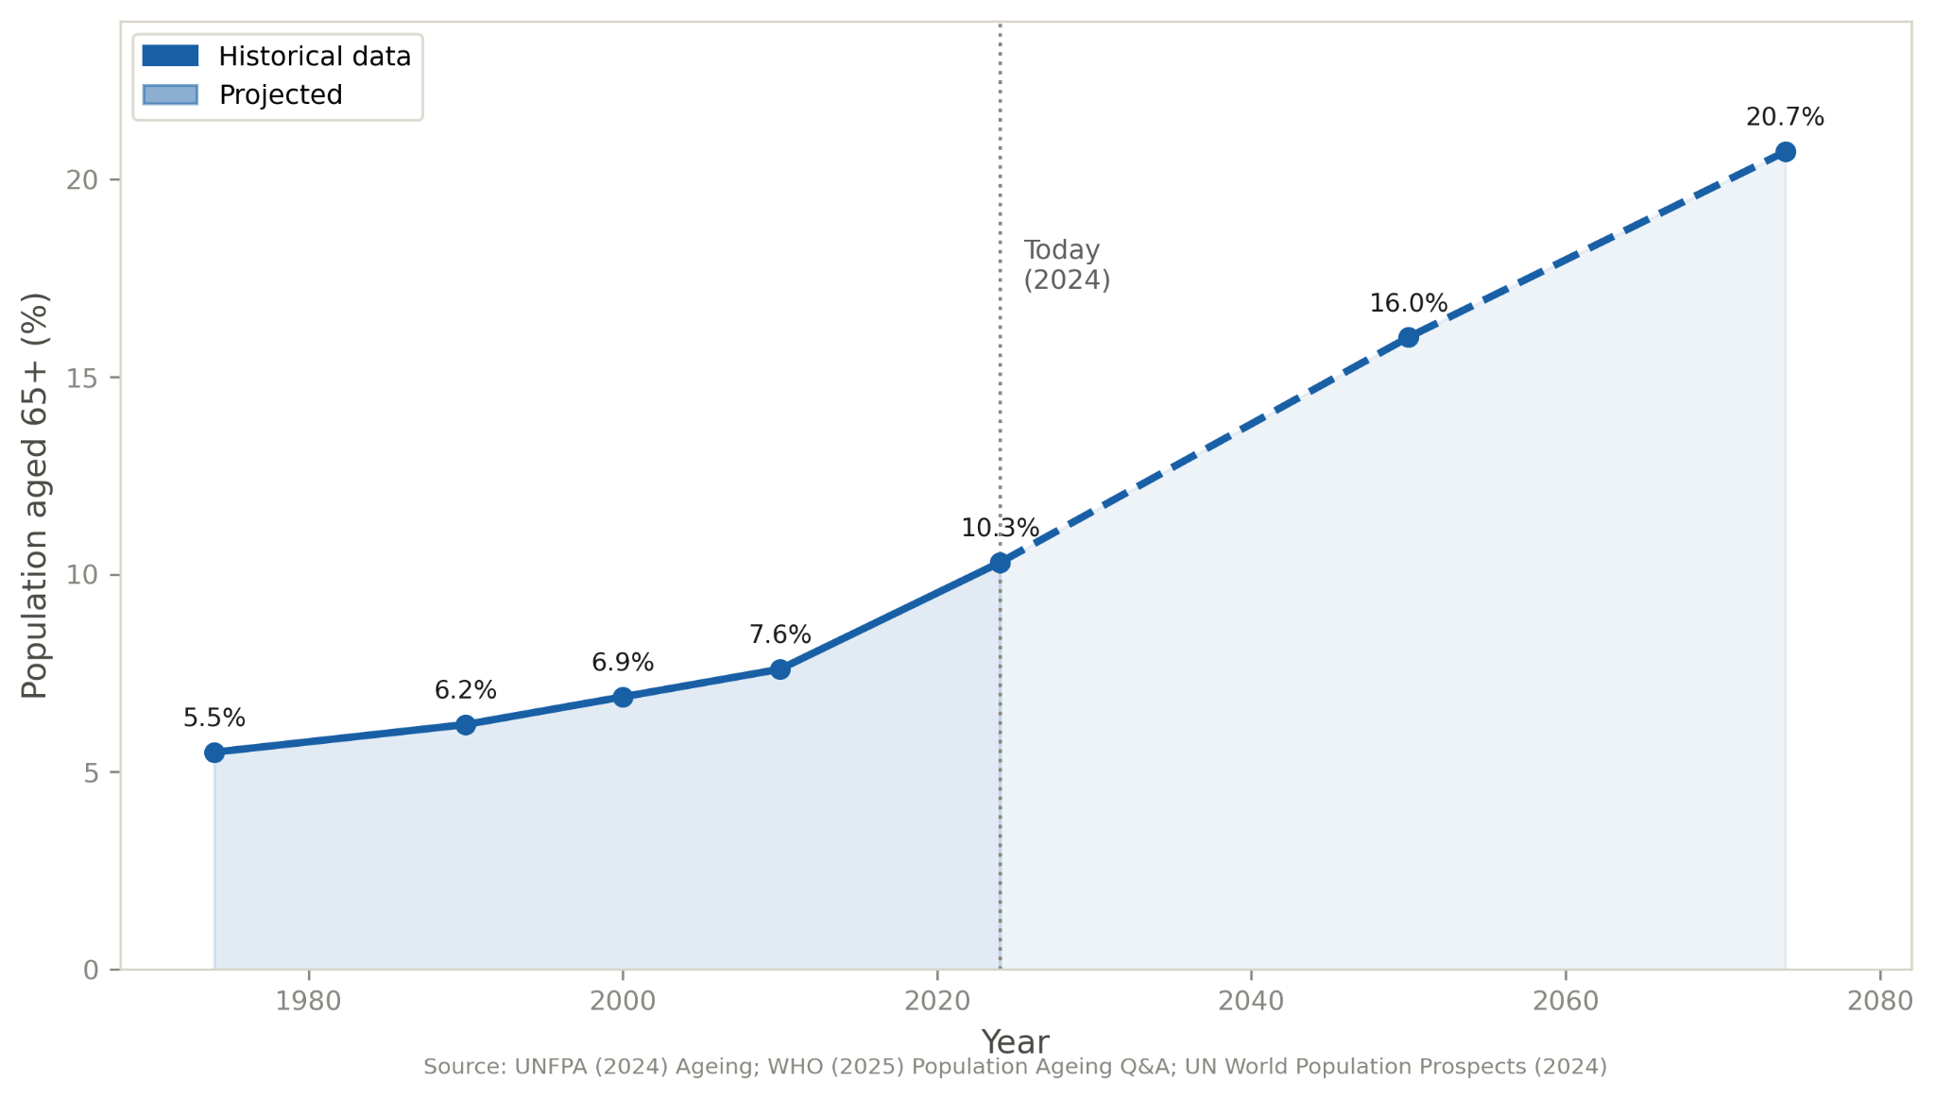
Figure1.1 Ageing population line chart
The domestic environment is usually a place that offers comfort due to familiarity. However, it fails to address many problems related to the effects of ageing. Simple chores, such as moving between different rooms, reaching for objects that are spread throughout the house, and sticking to the schedule for taking medication may prove difficult and dangerous. Fall accidents are very common among older patients because they occur while the patient moves from one room to another. In addition, as individuals age, they experience cognitive challenges, such as forgetting things.
Several underlying reasons give rise to the need for a mandate of home health care services. Weaknesses and lack of flexibility make an individual unable to undertake his/her responsibilities at home. Besides, mental disabilities and lack of focus make it difficult for them to adhere to treatment programs because they have to be supervised carefully to make sure that they take their medication at the right time. Additionally, there are emotional repercussions due to lack of socialization, which makes one feel lonely, especially when one is either a widow or living far away from family members.
Another factor adding to the problem is the fact that in many societies today, the number of elderly persons is equivalent to the number of people working. The parity of these numbers makes previous assumptions about caregivers for the elderly invalid [3]–[5]. Health care and social care systems find themselves under increasing pressure, which results in lengthy waiting times.
Caring of elderly people or impaired people is twofold: The physical support to help them with mobility aspects or chores completion and the human touch in the form of emotional support to cope with loneliness.
The use of assistive technology aims to implement the human capital without replacing them. When properly designed, assistive technologies help the caregiver in the physical tasks allowing him/her to focus on the human aspects of care.
In light of the current scenario, it becomes clear what goal the research proposal tries to set out. In essence, the research proposal calls for designing a smart humanoid robot that can help senior citizens at home. However, the scope of the proposed goal goes well beyond illustrating a single mode of assistance; the ultimate goal lies in incorporating a number of modes of assistance into a single comprehensive framework that takes into account the diversity of the needs established earlier. The idea behind the mentioned humanoid robot is to provide physical assistance with mobitiy aspects allow for a natural conversation by means of an intelligent interface that can be used even by those lacking competence in modern technology. The system uses the NAO humanoid robot in the simulation Webots to meet its goals. It should be noted that there is significance in choosing the humanoid form since this promotes more natural and emotional interaction which, considering the goal of providing companionship to the user, it is paramount. The system incorporates functionality including escorts, navigation inside the house, reminders, conversation, and communication between residents. The system utilizes architecture that includes assistive robotics with AI reasoning, indoor navigation, and human-robot interaction. The primary idea is to consider the problem as domestic assistance as opposed to simply a theoretical one because the focus should be on the right behaviors in a domestic context based on irregularities.
Another issue that emerges with regard to the emphasis placed on realism is that of the flexibility of the system to be used in any kind of domicile as opposed to working in a controlled environment in laboratory conditions. The elderly live in houses that show significant differences in terms of spatial distribution which makes it very inefficient to develop a robot in one particular area considering the scope of the project. In order to ensure flexibility, there must be semantic navigation, i.e., the ability to understand the layout in terms of meaning as opposed to coordinates, while adaptability can be achieved through modularity, dividing the layout in independent reusable components that represents meaningful parts of the environment..
The key problem in question in the current research relates to independence and quality of life. This is the main justification of the investigation itself. The matter is that , apart from the possibility of performing specific activities thanks to robots, it also has to do with keeping people independent and making them feel like they are in control. The fear of losing one's independence is greater for the majority of people than almost any other consequence of getting old. Staying home with help rather than staying under constant surveillance and control is extremely important in terms of preserving one's dignity and welfare. Helping people move safely, remind them of their engagements, and communicating with them can be considered the way to make them feel safe and secure, thus eliminating loneliness from solitary life. Nevertheless, it should be noted that the project does not imply replacing humans' efforts, because relationships, professionalism, and emotions can never be replaced by mechanical work. What is important here is adding another level of care [6].
The physical interaction scope in this project is purposely limited. The robot only deals with doors, using them to switch between rooms. It does this by sending commands to a door controller instead of actually grabbing the door itself. Because of this setup, the robot doesn't touch any other objects or structures. These extra interactions are saved for future upgrades. So right now, the focus is strictly on the robot opening and closing doors.
Having defined the problem and its objectives, as well as those of its possible solution, the next stage will be to contextualize the problem itself. To understand the existing status quo, it is necessary to analyze earlier works conducted on the subject and in the fields of assistive robotics, artificial intelligence, as well as all relevant background information used to develop home assistance robots.

Chapter 2 — Background Research
This technology is the product of several years of intense research into many different areas related to assistive technology, social robotics, and artificial intelligence. For the purpose of explaining how the development of such an assistive robot can be accomplished, it is important to understand the environment where this process is taking place. The purpose of this chapter is to explore the social environment within which research in social robotics would be relevant, determine which sciences contribute to such research, and evaluate criticisms raised against existing technology and science. In other words, the chapter does not merely review existing literature, but also critically analyzes it.

2.1 The Global Ageing Population
Global demographic tendencies have played an important role in shaping the direction of studies devoted to the development of technology that can be employed at care homes for older adults. During the last century, thanks to advancements in medicine, improvements in nutrition and living conditions, humanity has increased the life expectancy, therefore the number of elders and their related necessities has increased especially in the more advanced Countries. On the other hand, the number of births can not sustain the current population size. [1], [2], [7].
The result from such a scenario is a changing demographic composition in terms of an inverted population p Where the base of younger people is narrower than the cuspid of elder people. Population ageing emerges from such a situation, being referred to as a demographic process that sees the number of people aged above sixty-five in a higher ratio compared to the total working population.
The shrinking in the active population presents Significant challenges for the caring of eldo people. On one side the reduction of the Working population means a smaller economic contribution to the Social security and health care systems. on the other hand, less workers mean a smaller number of professional carers. In addition to this, the increased elder population comes with increased needs, both for economic resources and for workforce. Therefore, technologies become one solution that may help, because traditional approaches no longer work [3]-[5], [8]

2.2 Challenges Faced by Elderly People
In order to tackle the problems faced by elderly people, any kind of action should take into account the problems related to the ageing process. These kinds of problems can not be treated as isolated since there is a direct link between physical impairment, p sy co logical limitations and the problem of isolation.
The loss of physical ability is the main problem. Lack of muscle strength makes movements dangerous, leading to a high recurrence of falls, which may lead to immobility for elderly patients due to reduced healing capability after the injury. The problem can turn into a vicious cycle since the fear of an injury prevents the person from engaging in physical activities wich in turn reduces the physical condition and subsequently their ability to move.
In relation to Cognitive functions, people can be affected by a degraded cognitive system leading to loss of memory and difficulties to concentrate in simple tasks preventing in Sopreventing in some cases the effective medication intake. Finally loneliness, although not a disease, has a significant impact on the mental health of the individual affecting both physical and mental health. This is aggravated when loneliness is not Searched and is the consequence of the loss of a beloved one.

2.3 Assistive Robotics
Assistive robotics is a unique field that deals with the creation of robotic technologies designed to help people in performing certain actions, mainly targeting those individuals who are affected by aging, disability, or disease/recovery processes. Designed both for clinics and private homes, assistive robots provide physical assistance in moving and handling objects, cognitive assistance in recalling events or performing tasks, and emotional assistance by engaging in conversation and being company for patients. In elderly patients, such robots can help increase independence and improve quality of life through safety when moving around inside the house, picking up distant objects, warning during any kind of emergency, and eliminating loneliness thanks to conversation. According to different types of support that robots provide, assistive robots are divided into physically assistive robots and socially assistive robots [9] – [12]. In the range of various assistive robots, humanoid robots receive special attention due to their anthropomorphic design and behavior, making communication easier for the user, and hence more useful when working with elderly patients [13], [14].
To provide proper support under such conditions, certain requirements have to be met. The first requirement is safety, which means the robot should be incapable of inflicting harm accidentally on its user. Reliability is the next parameter since no one will make use of an unreliable system. Another requirement is usability, which aims to ensure that the robot accomplishes its tasks, and its able to understand simple language, making very easy the usage for a person that has never been or barely been in contact with technologies. At the moment, robots are reliable and predictable; they also have the capability to sense and react to various types of stimulation. On the other hand, they usually perform well in one aspect among the two main aspects which define an effective assistive robot – either good communication skills or good task performance abilities.[15]–[17].

2.4 Human-Robot Interaction
However, the efficacy of robots' job completion becomes meaningless if it causes any discomfort to its users; hence, the emphasis during interaction ought to be put on the creation of comfort alongside efficiency. Human-Robot Interaction (HRI) is defined as an interdisciplinary study that deals with human-machine communication, taking into account perspectives such as psychology, design, robotics, and computer science. HRI has a significant role in terms of assistive robotics because sophisticated yet complicated machines produce less-than-desired results [18], [19].
Communication in nature becomes more important than the actual process of performing an action in cooperative scenarios. For elderly people, it is easier to communicate with the robot because verbal conversation requires lesser energy and is not dependent on knowledge about the interface, motor skills, or depending on a physical remote. Thus, the ability to communicate through speech with a robot becomes an essential characteristic of robots designed for use by the elderly due to developments in the domain of speech processing [20], [21].
Furthermore, through verbal communication, the robot will be able to show proper emotional reactions and build trust with the user. People usually develop quick connections with robots, which can counteract feelings of loneliness; yet, the interface may pose some difficulties for seniors because of the specific physical, cognitive, and social characteristics associated with older adults. Designing a robotic system should also consider the possibility of developing an unhealthy dependence [22].

2.5 Artificial Intelligence and Large Language Models
It was difficult to achieve natural communication in traditional robots due to their scripted approach to dialogues that would make them capable of engaging only in certain types of conversations. One of the goals in using Artificial Inteligence (AI) in modern robotics is to improve the communication process by making it easier and more flexible. The use of conversational AI helps the robot understand human language, respond accordingly, Therefore conversing in a more human-like manner [23]
One of the most important advances in assistive robotics is the rise of Large Language Models (LLMs). The language models receive training through vast amounts of textual data and exhibit their capability in comprehending and generating natural language in a manner more flexible and context-aware compared to earlier rule-based approaches. The use of LLMs within the framework of assistive robots allows for more effective communication through free interaction rather than command execution based on a certain set of rules. The language models have the ability to understand the user’s requests regardless of their formulation, keep the context of the conversation, search for relevant information from previous dialogues, and reply accordingly. As such, LLMs can be especially valuable for assistive robots due to their potential for more intuitive interactions [24].
However, there are certain problems associated with incorporating an LLM into the assistive robot system. First, there is the problem of reliability, which is caused by the fact that the output of LLM is probabilistic, thus the output cannot be guaranteed. Second, the LLM may come up with responses which are valid but false. It is dangerous when it comes to issues where misinformation can lead to severe consequences, such as providing misleading information about one's health status and administering wrong medication. Third, there is the problem of latency, which affects the process as the output will have some delays in terms of the response time. This makes tasks that involve important decisions to include other safety measures. [25], [26].
The solution is impractically dangerous. The following is a strategy for solving this dilemma, whereby we combine both approaches, letting the language model perform the high-level actions, while giving responsibility for the crucial safety actions to the deterministic part [27]–[30].

2.6 Indoor Navigation and Assistive Autonomy
Movement is key in developing assistive robots, alongside conversational interactions. Together, these elements form how humans and robots communicate. The environment is ever-changing; people might choose different routes or do unexpected things. Furniture gets moved around, stuff could block paths, and doors open and close randomly. So, to get around well, a robot needs to make its own maps, figure out how to get where it’s going, and take the right actions [31].
Domestic navigation for robots is tough because of various obstacles. Some things, like furniture, stay put, whereas others, such as people or pets, move around. So, the robot needs to handle each situation differently keeping its path clear around fixed stuff and reacting fast to anything in motion. Above all, safety comes first, especially in homes with older folks who might have trouble getting out of the way [32], [33].
As noted earlier, homes differ enormously from one another, and that diversity is a defining feature of the environments people live in. A technique designed for one specific house does little good in another, which would sharply limit how widely the robot could be used. THe approach taken here avoids tying the robot to a single floor plan: rather than hard-coding one environment, it represents the home generically, as a set of semantically labelled rooms and doors. That representation is the same for every house, only its contents differ, supplied for each home though a configuration file, so moving the robot to a different house becomes a matter of describing that house rather than rewriting the navigation logic [34]–[36].

2.7 Existing Assistive Robotic Systems and Related Work
The themes covered so far, assistive robotics, HRI, conversational artificial intelligence, and indoor navigation, have each been subject of considerable experimental study, and a number of robots have matured to the point where they can be tested, deployed, and even manufactured commercially. The systems described below are a drawn from across these areas, and together they show both how far the field has progressed and the problems that remain unsolved.
PARO, a robotic device designed for use by older people, takes the physical shape of a baby seal and employs both tactile, auditory, and dynamic sensing in reaction to any physical contact made to its skin. The most important feature of PARO is the ability to affect the user's emotions without the need for speech [37] – [40].
Pepper's a good example of a social robot. It chats thanks to features like facial expressions that make it talk well, both visually and with sound. Yet, Pepper doesn't always have engaging conversations.
The Care-O-bot focuses on actually doing tasks and uses its sensors to avoid obstacles. But because it's really expensive, it's only used in labs, not elsewhere.
The Toyota Human Support Robot is an example of a mobile assistance robot. As such, the robot is defined by its small size, light weight, manipulation ability, and sensors, and has the ability to carry items for the user.
However, one constant that exists among all three kinds of robots mentioned above is that each kind has a strength, which is determined by the purpose for which the robot is used. For instance, the first kind allows for emotional satisfaction without any productive work done, while the second offers user engagement without being productive, and the third offers the light tasks such as retrieving objects.

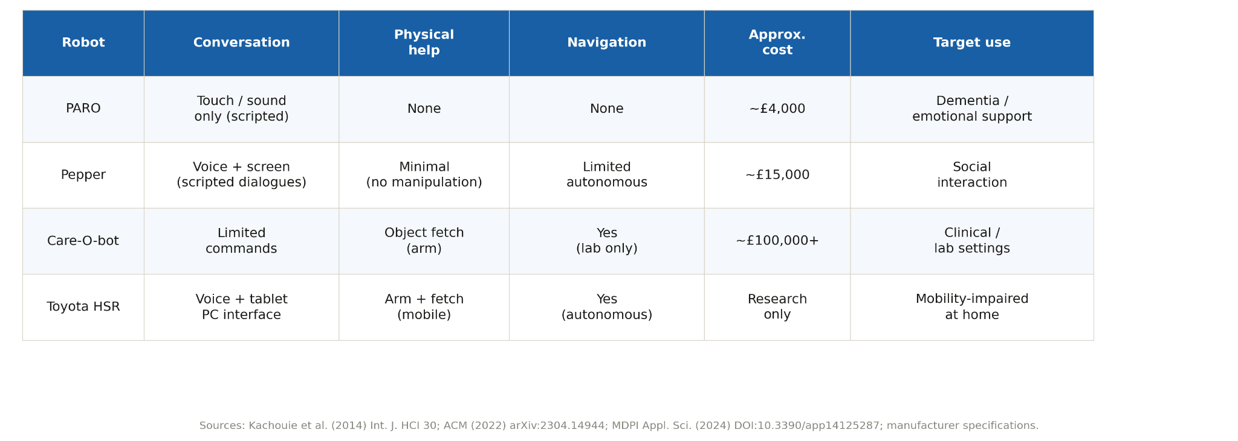
Figure 2.2 PARO/Pepper/Care-O-bot/HSR table

2.8 Research Gap and Motivation for This Project
In this regard, there is a clear gap where each of these two technologies has its own strength but does not incorporate other functionalities into a comprehensive system Several designs have served as a guide in helping navigate through space by considering the robot as a guidance tool. Meanwhile, others serve mainly as conversation devices, which are focused only on socializing. However, very few devices have been developed that have combined all these aspects by acting as both guides and conversation machines.
What's needed is a robot with artificial intelligence that can chat meaningfully with older folks, handle useful tasks safely, move around indoors easily, offer company, and help with housework. The main issue here is combining two very different tech types into one system. The first part is probabilistic AI think generative language models – which lets robots understand and reply to people in a natural way. However, it can be unpredictable. On the flip side, you've got planners, state machines, and safe action routines. These control movements and critical behaviors accurately and reliably but lack flexibility. Both systems do great in areas where the others fall short. So, the real challenge is blending these into a single system that keeps the adaptability of AI and the safety of traditional methods.
No current system does this combination just right, though. That’s exactly what we're aiming for in this project. Given the demands driven by population needs and current research, the next section lays out how to design such a system.

Chapter 3 — Project Vision and Planning
We need a robot with AI that can have meaningful conversations with older adults, do helpful tasks, and stay completely safe to use. It also needs to move around inside homes easily, be a good companion, and help with housework. The big challenge is combining probabilistic AI with dependable action control – making the system flexible yet robust. Such a robot doesn't exist yet, but developing one is possible.

Our research starts by figuring out what's needed for it to work well. We look at what the population requires, current science, and business goals. Then, we lay out a new plan on how to actually make this happen.

3.1 Vision of the Project
AI lets machines talk to people like we're just chatting normally, which is super cool. It can help make robots that assist elderly folks both practically and socially. At first, the robots mainly give physical aid, but now they do more than just follow simple commands. When these robots can chat, listen, and even know when it's okay to pause in conversation, they become real buddies. Because of this, they help out with tasks while also providing companionship, which is huge for the seniors they hang out with.
Now, the testing here isn't about proving theories or math stuff; it's just to see if the tech works well and makes sense. This fits into the second level of their setup, where all talks have to build on each other positively. Also, keeping away from too much tech-babble is really important.

3.2 An AI-Centred Design Philosophy
The robot is mainly seen as an autonomous buddy, not just a nav tool or chat device. So, it includes things like chats, memory features, and regular check-ins along with its usual nav tasks.
The drive to make this flexible system comes from past studies on how older adults use computers with language. Research shows a preset command list forces them to learn new vocab, while a more natural language style matches up with their queries. Like, both "Take me to the kitchen" and "I have to go to the kitchen" work great.
Thus, the main idea is there's a clear difference between building a responsive pal and a standard console setup.

3.3 The Choice of Webots and NAO
This study relies on two main things: the NAO humanoid robot and the Webots simulation environment. Webots is a big deal in both research and industry because it helps model and test robots, sensors, and more in a highly detailed 3D world. It has a physics engine too, which lets scientists predict how robots will act in real life by simulating things like collisions and gravity. Plus, Webots works with several programming languages and includes built-in models for lots of commercial robots, speeding up development and making experiments easier.
We picked Webots mainly for practical reasons. Testing risky situations, like falls or navigation mishaps involving seniors, is dangerous and expensive with real robots. Simulations let us catch these issues early and fix them before the actual robots go out. Plus, Webots comes with a Supervisor tool that gives researchers total control over the sim environment. It allows managing the robot and changing its setting, say moving a door or adjusting furniture. As a result, we can align the robot’s movements with enviro changes and start tests consistently each time. This helps in debugging and fair performance checks, making outcomes reproducible. All of this is super important for dependable robotics research [42]-[45].
NAO is a humanoid robot first created by Aldebaran Robotics and later bought by SoftBank Robotics. People choose NAO because it's great for socially assistive tasks. It looks somewhat human, can talk, and uses gestures – all of which help it interact better with humans. This makes NAO seem more like a friendly companion rather than just a gadget. Also, starting each experiment with NAO reset helps handle issues like going through doorways. Because even tiny changes in how NAO is set up can affect its performance, having that reset ready is really important.
NAO offers some great benefits but comes with drawbacks too. Sensors in Webots are way more accurate than those found in real homes, which face noisy environments. Plus, it’s easier to maneuver the robot in a simulation since it doesn’t have to deal with actual mechanical problems and real-world navigation glitches [46]–[48].

Figure 3.3 NAO Robot
The NAO Robot's small size limits its use in regular human environments. So, researchers made a tiny version of a home for tests, with super small doors and rooms. The robot navigates this mini space well, but such setups don't show the actual challenges of real homes.
The setup makes testing easier, and developers find it convenient; however, we still have more work to do. The robot needs extra tweaks to handle common household tasks. Also, we need to make sure it works in various homes, especially bigger ones, so comprehensive testing is key.

3.4 The Real Software Architecture
The software for assistive service robots doing domestic tasks needs to understand user commands, figure out what they mean, pick the right actions, and dodge obstacles. It also has to keep conversations going and know how to work with things like doors. To make updates easier, the design should let different parts of the software talk to each other.
So, it's split into modules: perception, communication, decision-making, navigation, and user assistance. These parts work together in a way that makes the robot helpful and good at interacting with people in a home-like setting.

The software architecture was made to handle what an assistive service robot needs in a home setting. It had to understand speech or text commands, figure out what users want, and then get stuff done. The robot needed to move around safely, chat with people, and work with things like doors. Also, it had to link different processes together and stay modular for adding new features down the line.
For this to work, the software was split into parts focused on particular jobs, like sensing the environment, communicating, deciding what to do, getting around, and aiding the user. All these pieces join up to make a unified system, letting the robot actually help and chat in a house-like simulator.
In terms of its setup, there are separate parts for managing speech and network stuff. The main boss is in the nao_assist_controller.py file – it watches over the whole show, helps make speech happen, and sets up TCP connections. TCP is there to make sure data travels reliably across networks. On top of that, you've got the voice_listener.py module. This bit uses SoundDevice to grab sounds and turn them into text thanks to the Google Speech Recognition API [58].

The control system looks at the data it gets and then figures out what to do next. It mainly gets its information from two places: commands sent by users over TCP and development data that comes through a special channel. The system handles lots of stuff at once by following a specific order.

First off, the system checks for any reset commands in the new messages. These resets get top priority because they help start a clean session if needed. When there's no reset command, a backup state machine kicks in. It goes through the message based on the chat flow, and if something's off, it triggers a parser. This tool can figure out the type of command and do things like navigate, operate doors, or make lists.

The state machine keeps working until all the messages are dealt with. Then, RobotBrain follows up on the textual commands. After handling the commands, the system runs through five stages—Understanding, Planning, Executing, Monitoring, and Re-planning—which lead to either success or failure [61]. At each stage, different parts do their crucial jobs. For example, the GenAIInterpreter figures out what the request means, the TaskPlanner decides how to execute it, the Executor does the actual work, and the ExecutionMonitor checks if anything needs fixing.
Two more services round out the system: CompanionBrain and the Assistive State Machine. CompanionBrain handles things like the robot’s personality, stores info on family members and meds, and keeps track of other related details. The Assistive State Machine, on the other hand, manages navigation and starts up getting help through dialogue.
For indoor navigation, the robot first builds a map using the Dijkstra algorithm. Then, it sets up waypoints inside rooms, uses sonar sensors to dodge obstacles while moving between points, and controls everything with a Behavior Tree Executor [60].

3.5 The AI Integration Strategy
This project isn't just about building an autonomous robot. It looks into how generative AI can work safely in assistive robotic systems. One big issue is that these AI models are stochastic – identical inputs don’t give the same output every time. They do great with human-like conversations and chat, but there’s a catch. These models might spit out incorrect or unforeseen stuff. Now, that's fine for casual chat, but it can be really risky when AI controls actual actions in the real world. So, we need to find ways to use their strengths while keeping everything safe.
The system combines AI with deterministic robotics by assigning clear duties to each part. To start, the developers set up the AI to figure out what the user wants and handle the chats. However, the robots themselves don’t get movement instructions from the AI. The robotic units follow strict safety rules for predictability and security instead.
Another smart decision is using several AI modules instead of one all-purpose model. There’s a dedicated module that decodes user commands and turns them into actions the robot can take. Another handles keeping the conversation flowing naturally and includes personal data storage—favorite things, family info, regular routines, and help needs. Splitting up the jobs like this keeps everything simple and stops potential chatter from affecting crucial functions.
To make sure it’s extra safe, any suggestions made by the AI must pass deterministic checks before being acted upon. So, while the language model can suggest things, only verified methods are actually used for task planning and execution. In the end, this setup mixes the flexibility of chat interactions with dependable robot task performance.
The design lets the robot work solo without cloud-based AI help. It uses integrated backup systems to do basic tasks via set rules and scripts. So, it doesn't depend just on external AI and keeps functioning despite issues. These strategies make up the main parts of the hybrid AI approach used in the project.

3.6 Navigation and Assistive Planning Philosophy
The proposed navigation approach is designed around the requirements of an assistive robotic system operating in a domestic environment rather than a fully autonomous exploration system. In contrast to traditional robotics navigation methods that prioritise continuous autonomy, the goal in this project is to support human-guided interaction, where movement is initiated by user requests or assistive needs. This ensures that the robot behaves as a responsive assistant, operating only when required rather than independently exploring the environment.
To achieve this, the environment is conceptualised at a higher level of abstraction than conventional occupancy-grid-based systems. Instead of representing space as a dense grid of traversable cells, the environment is modelled as a graph structure in which nodes correspond to meaningful locations (e.g., rooms or functional areas), and edges represent feasible transitions between them. This representation shifts the focus from low-level motion planning to high-level decision-making, allowing navigation to be expressed in terms of destinations rather than incremental movements.
Within this framework, assistive navigation is treated as a goal-directed process in which the system determines whether and how a requested location can be reached. The key idea is that navigation is not continuous autonomy but a controlled service: the robot is activated when escorting or guidance is required, and it returns to an idle state once the task is completed. Path selection is therefore based on identifying the most efficient route between graph nodes while respecting environmental constraints and safety considerations.
This design supports predictability and transparency in robot behaviour, which is essential in assistive scenarios such as elderly care. By structuring navigation around high-level locations and controlled activation, the system avoids unnecessary autonomous behaviour while still providing reliable guidance when needed.

3.7 Development Methodology and Iterative Planning
The system came together using an iterative, simulation-driven method. They made design choices based on what they learned from their experiments, adjusting as they went. Instead of sticking to a set plan, the team did cycles of implementing changes, simulating, analyzing errors, and tweaking parameters.
Unlike the V-model's neat path from requirements to testing, the robotics build showed more flexibility. With interactions being hard to predict, tests brought up lots of unforeseen problems. So, many of the early guesses had to be changed when they got actual results from simulations.
Big hurdles turned up while they tested too – mostly around keeping the bot steady and dealing with different environments. During early runs, it kept toppling over and struggled with doors. These hitches showed that first thoughts on how sensors and motors worked weren't spot on. To fix it, they had to shift some rules and tweak navigating methods till things got better.
They solved problems through trial and error, kind of like in the Spiral model. It has rounds of assessing risks, making prototypes, and evaluating before moving on. These trials helped spot and deal with glitches early, fixing issues with the robot’s movement.
Learning from what actually happened with the robot gave much clearer guidance on fixing things than just theories. All this checking and adjusting with simulations really brought the tech to life. By mixing exploratory work with constant testing, they ended up with a reliable machine ready for real-world assistive tasks, and that's super helpful.

3.8 Project Planning and Implementation Stages
The development process stuck to a structured, step-by-step method. At first, we set up the environment and platform components, like the Webots simulation, the NAO robot, the controller, and the Supervisor—which knew about the door's state and position. After that, we added voice recognition to change speech into text. Next came boosting the AI for better communication; this meant building a command parser and an assistant that could follow conversations.

Once those parts were done, the logical and motor systems grew mature enough to integrate into state machines. For this, we came up with a new design that wasn’t grid-based but had traits of a hierarchical planner instead. The assistant's state machine worked predictably through the interactions. By the end, we fit interpretation, planning, execution, and monitoring all into the state machine setup. We wrapped things up with real tests, revealing a key piece of info about AI.

3.9 Critical Analysis of the Architectural Decisions
The main benefit of the design is its modular structure. This lets developers test parts individually, making maintenance and debugging way easier, especially in robotics where problems usually start with one subsystem. Plus, separating the probabilistic language processing from the robot’s tasks ensures safety by blocking unsure commands from having direct control.
Another great thing is how adaptable the system is to different environments thanks to its configurable room layouts and settings. There are downsides though. It works best with regular language inputs, so if someone's speech deviates too much, it becomes less effective. Also, depending on cloud services means lag and trouble whenever there's an internet issue.

Some worry about undetected errors because independent monitoring might struggle in changing circumstances. Even though Webots offers strong simulations, it doesn't cover every real-world problem, meaning tests might not work perfectly once moved from virtual to real setups.
Overall, the design tries to balance modularity, safety, and practicality. It sets base choices that have implications for bigger discussions. The next part looks at the actual development and changes made along the way.

Chapter 4 — Project Implementation

4.1 Introduction to the Implementation
The previous chapter described the system in principle; this chapter describes the system that was actually implemented. The layered architecture, hybrid AI philosophy, and assistive objectives all had to function within a live simulator, interact with a real language model, and operate under the physical constraints of a humanoid robot that is prone to instability and falls. As a result, much of the implementation process involved discovering what worked in practice, what failed, and what required redesign. The primary challenge was not the invention of new technologies, but rather the integration of existing components. Speech recognition, language models, path planning algorithms, and finite state machines are all established technologies; the contribution of this work lies in making them operate together in a coherent system where intelligent interaction results in meaningful action while probabilistic uncertainty is prevented from influencing physical movement.
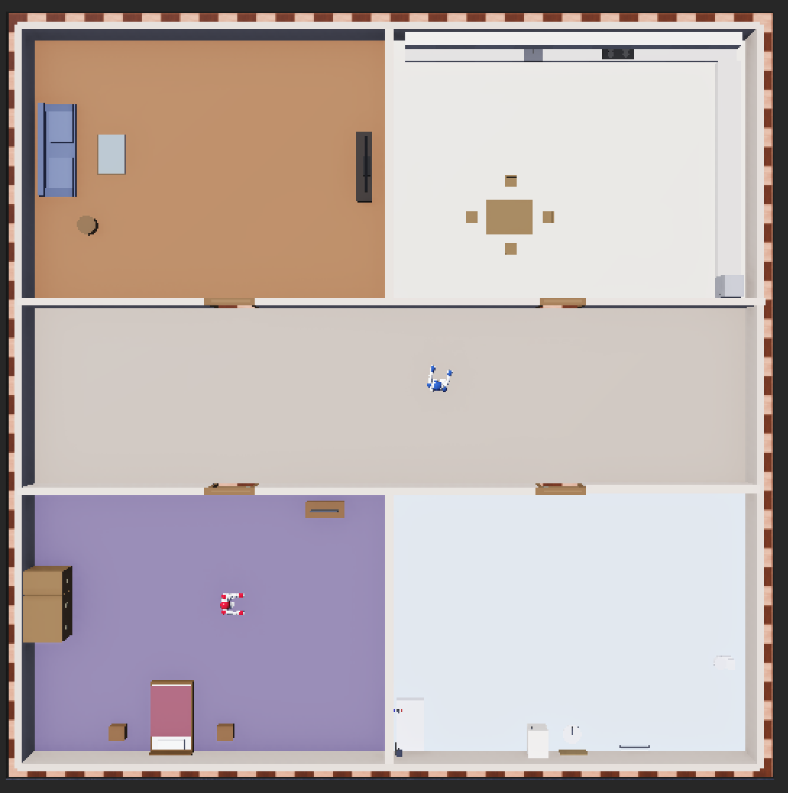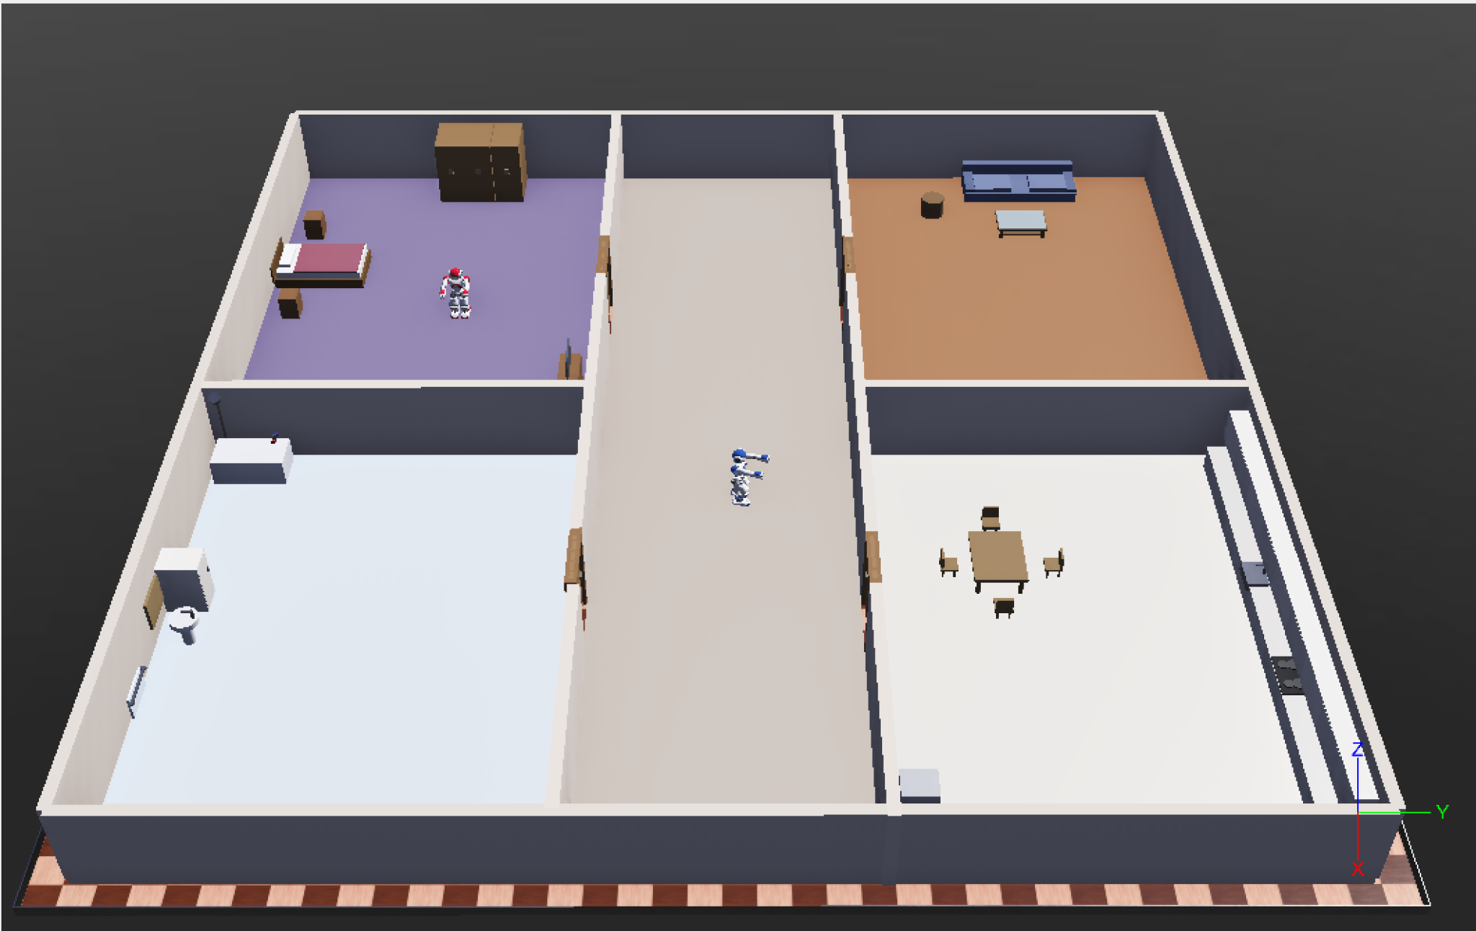
Figure 4.4 Upper view layout house Figure 4.5 Side view layout house

4.2 Overall System Implementation
The system operates as a collection of cooperating processes rather than a single monolithic application. Within the Webots simulation environment, two controllers execute concurrently: the service robot is controlled by nao_assist_controller.py, while environmental doors are managed by door_manager.py. A third process runs independently outside the simulator and is responsible for capturing and processing voice input. This separation ensures that speech-recognition failures cannot interfere with the robot's primary control logic.
Communication is achieved through two distinct channels. Spoken commands are transmitted to the robot controller as text via a TCP socket on port 5005, while door-control messages are exchanged between the robot and the door controller through Webots' emitter-receiver mechanism using radio channel one [53], [54].
At the centre of the implementation is the controller's main execution loop. During every simulation step, the loop advances the assistive state machine, allows the companion subsystem to operate whenever no active task is in progress, and processes incoming text commands received either through TCP communication or a development command file. Requests are handled according to a strict priority order: system resets are processed first, followed by assistive state machine actions, and finally general command parsing. This ordering guarantees that active assistive tasks always take precedence over conversational interactions.

4.3 Conversational AI Implementation
The conversational subsystem is divided into two complementary components that share the same language model while serving different purposes. One component focuses on command interpretation, while the other provides companionship and social interaction. Both rely on Claude Haiku and are designed to continue functioning even when the language model becomes unavailable.
Command interpretation follows a two-layer approach. Initially, a deterministic parser performs rapid analysis by removing conversational filler phrases such as "please" or "could you" and classifying requests into predefined categories, including navigation commands, escort requests, door operations, and room-list queries [55]. Commands that can be identified with certainty are executed immediately without requiring any network communication.
Only when a command cannot be classified deterministically is it passed to the GenAIInterpreter. This component prompts the language model to return structured JSON corresponding to a limited set of recognised intents, including navigation requests, multi-step tasks, door operations, and unknown commands. The language model therefore handles ambiguous or naturally phrased requests while remaining constrained to interpretation rather than direct control.
The companion subsystem addresses the social and emotional aspects of interaction. Before consulting the language model, deterministic filters identify situations where generated responses would be inappropriate. These include requests involving memory, family information, medication schedules, signs of loneliness or illness, and practical questions such as time and weather. In these cases, responses are generated through predefined logic, and relevant information is stored within the user's profile.
Only after these checks are completed is the message passed to the language model. The model is instructed to maintain a warm and supportive tone, avoid identifying itself as an AI language model, and never provide medical advice. Proactive interaction is implemented through a periodic companion tick that operates whenever no assistive task is active. This mechanism allows the robot to greet users, suggest activities, encourage hydration, and deliver medication reminders based on schedules stored within the user profile [56].
The resulting conversational architecture operates across three layers: deterministic handlers, generative responses, and scripted fallback mechanisms. This design provides fluent interaction while maintaining robustness during network failures, although some variation naturally exists between deterministic and generated responses.

4.4 Voice Interaction and Communication Systems
Speech input is handled by a dedicated component, voice_listener.py, which operates as a separate process independent of the main Webots simulation. The listener captures short segments of audio sampled at 16 kHz using the SoundDevice library, converts them into an in-memory WAV stream, and submits them to Google's Speech Recognition API for transcription. Once the transcription is received, the text undergoes a normalisation stage in which polite expressions such as "please" and "thank you" are removed, abbreviations and room names are expanded into executable commands, and predefined phrases for actions such as ending a task or requesting available destinations are identified.
The decision to run speech recognition as a separate process was made to prevent blocking the simulation loop. Audio capture and cloud-based transcription introduce delays that could temporarily freeze the robot if performed directly within the controller [59]. By isolating these operations, speech processing can occur independently while also simplifying debugging and maintenance. The listener is capable of automatically re-establishing communication if the connection is interrupted, and the communication channel carries both the recognised command and the identity of the user issuing it.
Despite these advantages, the approach has several limitations. The quality of speech recognition depends on internet connectivity and the availability of a third-party transcription service. Any transcription errors can directly affect comma4.8nd interpretation, potentially resulting in incorrect robot behaviour. Furthermore, the use of a fixed recording window makes interactions less natural than continuous human conversation, as users must adapt their speech to the system's listening cycle.

4.5 Navigation System Implementation
Navigation turned out to be the hardest component to develop. First and foremost, what makes finding important is the necessity of conducting sophisticated mathematical calculations when performing simple tasks like going inside the room for a person with impaired balance. On the contrary, planning appears to be relatively easy. One should note that the robot does not go from one coordinate to another; it only looks for an optimal path to follow. In the first stage of planning, the world is represented in the form of weighted graphs where the nodes are rooms while the edges are connections of the hall between these rooms, and the algorithm that is utilized for planning is Dijkstra's algorithm. This allows finding the shortest way without approximations typical for other heuristic algorithms like A*. To create a navigation path, the TaskPlanner takes advantage of existing doors in the building plan and avoids walls, which caused multiple problems in the past. The path is expanded into real coordinates that include doors and entrances used on that path, thus allowing the robot to plan its steps at certain waypoints and rerun the search if any of the passages was blocked. In this case, the TaskPlanner builds the graph taking into consideration possible obstacles near the area based on the possible map inaccuracies. Next, the TaskPlanner builds a chain of actions consisting of approaching the door, keeping the distance from it, opening it, going through it, and moving towards the destination.
A crucial thing for planning involves the points where the rooms meet. In the event that the robot is coming from a room outside of the planned area, then a transition point becomes necessary for the robot to be able to leave that room. Failure to establish a transition point will mean that the robot can easily move out of that room.
The problem mainly revolves around the execution stage, which turns out to be the most complex and updatable module. The actions were associated with functions which produced outputs in terms of return value information, completion information, and reasons for failure, respectively. Movement makes use of the locomotion controls to make progress towards the target under stability protection. In terms of door handling, the door control module handles the request made, waits for its results, and allows the robot to walk through the new path created through the door. However, it was noted that there was no need to have the exact positioning of the robot before entering the door, since the act itself destabilized the robot. The movement approach uses two algorithms which calculate the center of the opening and hinge angle of the door.
Generalization across domestic settings can only be achieved by changing configurations and not altering the code of the program. Such parameters as centers of rooms, entries into rooms, borders of rooms, and corridors are stated in configuration files, and hence, the achievement of the goal can be accomplished through configuration alone. The least generalizable aspect of the program lies in the process of transitioning from one door to another, which is bound by some geometric assumptions, whereas other aspects such as how to leave a room are not.
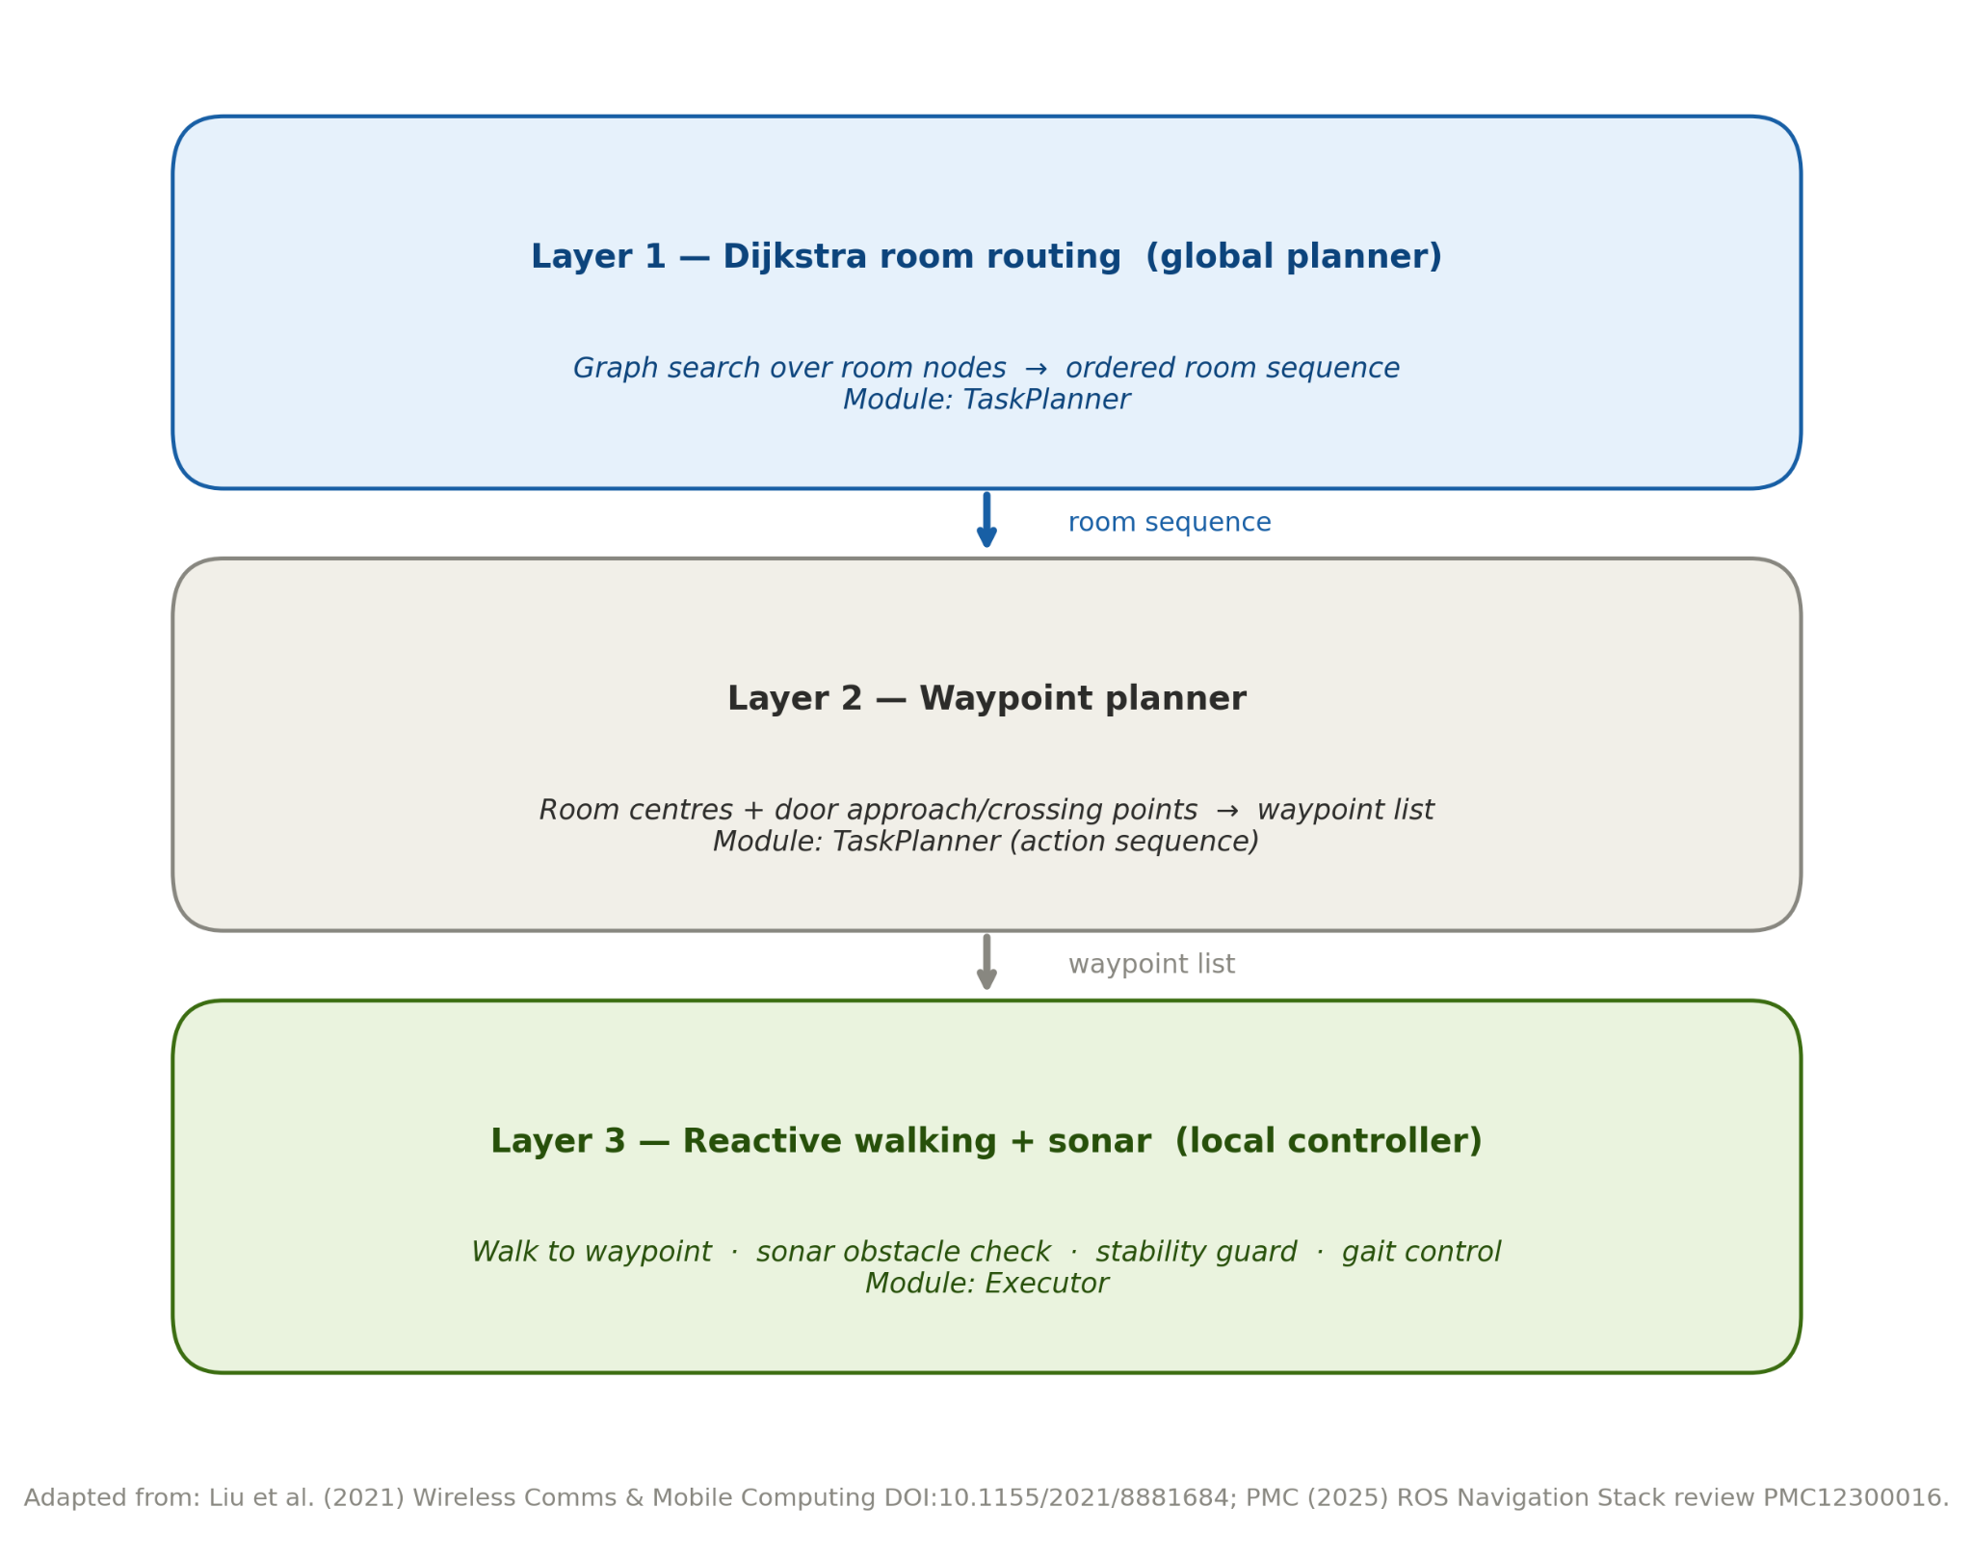
Figure 4.6 Navigation Layers Diagram

4.6 Assistive Task Implementation
The assistive behavior of the robot is controlled by a self-governing finite-state machine based on mechanisms similar but different from those utilized for navigation purposes; such behaviors are disabled on initialization. In case the robot is asked to help a person reach a certain destination, the robot will stay motionless until the location of the person has been determined. The algorithm begins with being in an idle state, moves into being in a state where location status is awaited, but only when the right name of the room is acquired; otherwise, there will be no effect on the process [62]. Having gone through several attempts and not moving for about thirty seconds, the system goes back to its original state with some encouraging messages.
The implementation of the dispensing drugs procedure relies on the second and scheduling protocols, which need constant modification in response to feedback from users in order to enable the work flow to take place within the framework of an audited protocol and not just a generated dialogue [57]. The procedures in the fetching objects protocol are similar to those that have been discussed before, where the robot goes to pick up an object that is located in a pre-set position and then proceeds to deliver it to another pre-set position.

4.7 Environment Interaction
The motion of the doors is regulated using an automated control process in which when there is detection of either of the signals "open [key]" or "close [key]" at channel one, then the motors are started in order to open the door. The robot, which is responsible for issuing orders to the other subsystems, uses home automation so that the door can be opened for testing due to multi-channel communication of the robot with its surroundings. There are times when the robot needs to open the door before entering into it.

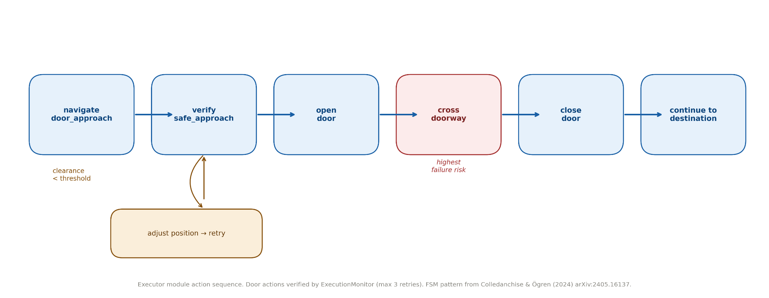
Figure 4.7 Door opening diagram

4.8 Iterative Development Process
The system evolved incrementally through multiple development iterations rather than being implemented directly from a complete design [65]. As testing progressed, several components were redesigned to address limitations identified during simulation. For example, the navigation subsystem evolved from an initial grid-based approach towards a higher-level room-to-room navigation model, while the door-crossing mechanism underwent several revisions before reaching a reliable solution.
Door traversal proved to be one of the most challenging aspects of the project. Repeated testing revealed failures caused by inaccurate alignment, heading tolerances that were too permissive, and movement patterns that resulted in oscillatory behaviour near doorways. These issues manifested differently depending on the environment and doorway configuration, demonstrating the complexity of translating planned navigation into reliable movement. Furthermore, modifications that improved performance in one scenario often introduced new issues in another, requiring additional refinement and validation.
This iterative process highlighted the importance of simulation-driven development, where continuous testing and evaluation guided architectural and algorithmic improvements. Rather than following a fixed implementation path, the final solution emerged through repeated cycles of experimentation, analysis, and refinement.

4.9 Testing and Debugging
Evaluation was done by simulation and by the analysis of the robot’s behavior in terms of extensive logging of all components in a control console. Logging made it possible to track the entire process of navigation, which included not only the pre-calculated path, but also the coordinates of the room being navigated to and the calculated path using Dijkstra algorithm. It was easier to identify what subsystem was experiencing problems without making assumptions. Sometimes what seemed to be problems related to programming of the robot turned out to be a poor configuration, like the selection of improper coordinates.
Various kinds of faults have been noted, primarily physical in nature, such as hitting the door frame, stumbling on crossing over from one room to another, being unable to move forward despite all efforts, oscillation near the door frame, and in some cases, even entering other rooms through an incorrect path. On occasion an unusually phrased request slipped past the deterministic handler and was routed to the language model instead. Yet, various tests undertaken managed to reduce faults associated with the door.

4.10 Requirement Analysis and Implementation Evaluation
Measured against the goals defined at the outset, the implementation meets almost all of them. In other words, the robot recognizes the owner, speaks in a human-like way, understands commands, moves from one room to another opening doors, accompanies the identified person and warns about medications. At the same time, the efficiency of such an approach was proven.
Still, there exist some aims that are partially achieved. First of all, the robustness in case of moving through doors may be considered the weakest part of the system. Moreover, the rest of the program that is written for the specific rooms depends on the predefined design. At last, the major disadvantages are related to the work of the monitoring program. Although a reliable module that can detect stall, deviation and repetition is created, the main program loop does not contain any updates but only re-tries. The process of object acquisition is rather obsolete and even causes simulation stops.

4.11 Critical Technical Analysis
The key benefit of the system is that it is modular. Particularly, the speech recognizer, interpreter, planner, actor, monitor, dialog, coordinator, and door actuator can all be tested through separate interfaces and channels [63]. Such an arrangement allows for debugging while providing an opportunity to change the speech recognizer and interpreter without affecting other modules. The mixed probabilistic and deterministic decomposition turned out to work well, as errors occurred in the speech recognizer as incorrect sentences rather than total breakdowns of the system.
This issue comes about as a result of the interface between two different systems. In the incorporation of the generator inside the walker, we introduce another possible point of failure in both the areas; validation, re-attempts, stabilization, and enlargement of buffers create further complexity in this system. Since latency is unavoidable, the generative system will always be behind a deterministic system in non-real time environment [64]. The part of the system that will pose the biggest issue in terms of maintenance is the executor.
The fact needs to be taken into account that the tests were performed under simulated circumstances. The Webots simulator allows perfect sensing, permissive physics, and perfect world knowledge under the Supervisor mode. None of those is available under the circumstances of a common household environment. In this regard, there will be problems that will arise for the real NAO robot walking on a common household floor in the real environment that cannot be achieved by simulation.
However, the deployment of the system produces a useful tool that understands its shortcomings and capitalizes on its strengths to aid the users effectively. Yet, it needs a broader evaluation of itself, and this will be conducted in the next chapter to see if the goals have been accomplished.

Chapter 5 — Evaluation and Critical Reflection

5.1 Introduction to the Evaluation
An AI system's effectiveness goes beyond just its tech working properly. With assistive robots, we need to look at how well they perform and how helpful they are for users. So, a navigation system that gets you where you need to go but makes you anxious isn't good enough. On the other hand, a chatty system that can't handle your personal info isn't cutting it either.
That's why this chapter looks at the robot and AI as one combined system, not separate pieces. Just working correctly isn't enough; all the parts need to mesh well to offer safe and useful help. We focus on spotting problems and what could be improved, as well as highlighting what works, to give a fair view of the system's pros and cons.

5.2 Evaluation of the Original Objectives
When looking at how the project measures up to its goals, it mostly checks out positively. Still, some areas did better than others.
The standout success was how well the chatbot handles conversation and support. It can recognize users, have genuine back-and-forth chats, not just read scripts, give personalized med reminders, and even keep users company [73].
The robot also did great with guiding tasks. But here's the thing – it adds an important safety measure. Before it moves anywhere, it asks for confirmation to make sure that's where the person actually wants to go. This way, it respects the user’s choices without getting in the way of their independence [69]. That really hits the target of the project: making everything focus on the user.
The robot's achievement of goals differed. It can move between rooms and go through doorways, but its success depends a lot on the situation and environment. Also, its navigation relies on a map made ahead of time instead of figuring out its surroundings in real-time. So, it works well in familiar areas but struggles when faced with somewhere new—still lacking the flexibility to handle unknown places.

5.3 Evaluation of the AI Systems
Integrating generative artificial intelligence is a key part of the project and a main focus of the evaluations. It lets users have conversations with the robot like they would with another person, not just give it orders from a set list. This makes it easier for lots of different people to use, especially older folks who aren't that tech-savvy [68].
Plus, it personalizes your chats by saving your info and preferences. There are downsides though; generative AI can be inconsistent and unreliable at times [70]. It might even give different answers to the same question, making it less predictable.
To handle these problems, the designers make sure to limit AI use in important areas. They keep the natural language and chat features separate from moving around and doing tasks. The movement and task parts follow strict safety rules, while they let the conversation AI do its thing. This way, critical functions stay reliable, while conversations remain flexible [71].
Additional safeguards help minimize the risks from chat AI too. They keep functions that deal with health issues, like giving medical advice, out of the AI's reach. Instead, these systems guide users to real healthcare providers or experts [56].
Also, backup plans ensure stuff still works okay when AI services go down.
Overall, this review shows the blended method really blends the generative AI's flexibility with reliable, rule-based controls nicely. This system doesn't aim for machines making their own calls so much as providing a conversation that feels more human while sticking to safety rules.

5.4 Evaluation of Navigation and Assistive Behaviour
The navigation system clearly shows differences between route planning and actual movement. For planning, it uses a big-picture view of the space as connected areas, not focusing on exact spots. This way, it figures out good routes easily in places like homes.
Moving objects around is tougher. Robots handle going from one room to another and dealing with doors, but getting from point A to B requires careful thought and action. Passing through doorways is super tricky because robots need to maintain balance, position accurately, and work with different room layouts [72]. Still, they usually get the job done, though sometimes they need little tweaks to move smoothly through doorways.
One of the strongest aspects of the navigation subsystem is the escort functionality. By decomposing navigation into a sequence of dependent actions, the robot is able to guide users towards a chosen destination in a controlled and predictable manner. This behaviour aligns well with the assistive objectives of the project, as each stage must be completed successfully before the next action is performed.
Despite these strengths, the system remains dependent on assumptions about the environment. Navigation relies on a predefined representation of the home, and several movement strategies have been tuned to the characteristics of the simulated environment. Consequently, while the system performs effectively within known settings, its ability to generalise to unfamiliar homes or environments with different layouts remains limited and would require additional perception and adaptation capabilities [30].
Navigation systems differ when planning routes versus handling real-time movement. For route planning, these systems look at spaces as linked areas, not fixating on pinpoint exactness. This actually helps in finding good routes, especially around homes.
Real-time moving is tougher. Robots can go from one room to another and handle doors, but figuring out the whole trip needs more care. Passing through doors is tricky; robots have to keep balance, figure out where they are, and adjust for different room setups. Usually, though, they make it work by tweaking their approach slightly for smoother door crossings.

5.5 Evaluation of the Architecture and Implementation
Modular architecture is a big deal in engineering. Tasks like speech processing, planning, navigation, and interacting with the environment are split into separate parts. This makes it easier to maintain, test, and expand the design.
During development, breaking things down was really helpful. Teams could check and fix problems in individual modules without messing with the whole system. This made finding and fixing faults much simpler. Also, using state-machine logic for behavior really helped. It clarified and made runtime operations easier to track.
That said, not everyone got the same benefit from modularity. As development went on and new needs popped up, some system parts got way more complicated. Specifically, the execution and coordination components had to handle extra cases that came up during tests. So, understanding and maintaining these modules became harder compared to the higher-level layers.
The monitoring mechanisms show a similar trend. Sure, the system can spot failures and weird behavior, but a lot of its features aren't used right now. Because of this, some of what the designers intended for reliability isn't happening in real life. This shows a common issue in software development: even though modular designs give a clear structure and have lots of benefits, fixing things over time can make the system more complex and mess up the initial neat design.
Overall, the architecture stays organized and manageable. Still, we need to focus on making the execution layer simpler and fully using the existing monitoring abilities moving forward.

5.6 Testing and Iterative Improvement Analysis
The development focused on testing and refining things as they went along, not sticking to a set plan. To catch and study problems, they kept running simulation tests and made fixes based on what they learned. Logging everything was super important too – it gave them sight into every stage and helped pinpoint where things went wrong.
Turns out, lots of issues came from setup mistakes, not actual code problems. Like, bots getting lost? Often due to environment settings being off, not because the navigation system sucked.
These tests weren't just for checking; they shaped the architecture too. Watching, diagnosing, and isolating faults influenced how the system was organized. It reinforced separating interpretation, planning, doing, and watching [74]. This setup made it easier to trace actions and find failures, driving the whole thing forward.
The assessment highlighted the gap between theory and practice. What looked simple in the plans turned out to be much harder in simulations.Doorway traversal showed up as a major issue, needing lots of tweaking to work properly. These findings show how important it is to test robots repeatedly. You often find unexpected challenges when you look at how the actual system behaves, stuff you can't predict in the early design phase.

5.7 Limitations of the Current System
The main problem with the project is that it only works in a simulated environment. While Webots is great for development and testing, the situations it creates just aren’t as unpredictable as the real world [66]. In the sim, sensors give cleaner data, you get better info about the environment, and physical actions are way more foreseeable with a digital robot compared to a real one [67]. So, moving around, avoiding obstacles, and navigating doorways will probably be much harder in an actual home.
Another big issue is how the robot figures out where it is. It uses mostly pre-set info from the simulation rather than determining its surroundings like it would in the real world – by vision or complex sensor data. Although it can detect things using sonar, this isn’t good enough to handle the randomness and diversity of actual, unstructured settings.
These limitations affect the whole system. The robot can't navigate well in unknown places, making it hard to adjust to new or changing settings. Also, its ability to understand conversations relies on set interpretation methods which aren't strong enough for more flexible, natural chats. Safety features aren't fully developed either, so there's still work needed for deployment in actual assistive roles.
The project does show that combining assistive robots with AI is possible in simulations. Still, we've got a long way to go before we can call it ready for real-life use, especially when it comes to perception, dealing with variations, and adapting to dynamic environments.

5.8 Societal and Ethical Reflection
This study looks at the challenges of an aging population and how assistive robotics can help keep older adults safe and independent at home. These systems can remind users of tasks, offer basic help, and improve their quality of life. They also ease the load on caregivers and family. But the tech isn't meant to replace human interaction; the robots can't match the empathy and bonds humans form.
So we need to be careful about using these robots. It's key to see them as additions to human care, not as substitutes. For that reason, safety comes first. Since the robots work with potentially vulnerable people in their homes, controlling their actions properly is super important. Hence, designers limit the robots' autonomy specifically to reduce any potential danger.

More ethics come into play with trust, acceptance, and reliance on tech. While chat bots can help and keep folks company, we need to ask if users see them as real helpers or just tech replacements for humans. This looks at bigger social issues too, going beyond the tech details. We need to explore these first before thinking about rolling out these robots widely.

5.9 Personal and Technical Reflection
This study shows that combining AI with physical robots greatly increases system complexity. Both components bring big challenges on their own, and putting them together adds more uncertainties – especially since AI makes probabilistic decisions while the robot's actions are fixed.
Because of this, a lot of research focused on minimizing the risks posed by unreliable AI in key tasks, instead of expanding functionality. A major lesson is to keep separate the parts of the system responsible for interpreting data and the bits that control actions predictably.
Safety features need very reliable controls; therefore, AI should only handle data analysis and interactions. This setup keeps vital functions stable, even when the AI acts oddly or malfunctions.
The project also reinforced a practical understanding of system architecture, particularly in the context of modular robotics systems and human–robot interaction. Managing communication between components, maintaining system stability, and ensuring safe behaviour in an assistive context required continuous consideration of both technical and user-centred factors.
Overall, the development process demonstrated that iterative refinement and failure-driven learning are central to building reliable robotic systems. The final system represents not an idealised initial design, but the outcome of repeated testing, correction, and adaptation to real limitations encountered during development.

Chapter 6 — Conclusion and Future Work

6.1 Overall Project Summary
This study looks into whether combining generative AI with robotic systems can create an intelligent helper for elderly folks at home. It makes sense for two main reasons. First, the growing number of elderly people means there's a big need for tech that provides continuous aid and companionship. Therefore, it’s crucial to see if we can blend these components into one handy robot.

6.2 Summary of Achievements
This project started as a concept and ended up creating a system that shows what it can do. Generative AI serves two main purposes: first, it turns your voice command into something real; second, it gives you constant help and company. Before the system gets to work, a deterministic parser checks things out, with a hardcoded backup for when the system isn't available.
It also includes extra features like remembering users, saying greetings, and keeping extended conversations going. Plus, it'll remind you about meds and chat if you're quiet. If you enter a room, the system notices and handles that too. Room changes use a planner with layered thinking for different spaces, while each door is controlled on its own.
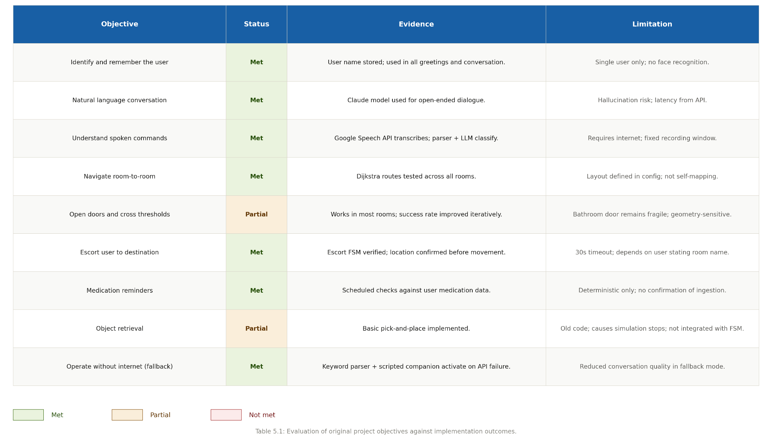
Figure 6.8 Requirements success table

6.3 Contribution of the Project
At heart, what matters isn't the individual parts but how they work together. Right now, most robotic helpers are great at just one thing—maybe talking, maybe making people feel cozy, or perhaps just delivering items. They struggle to combine different tasks in one gadget though. This new idea tries to blend chat skills from generative AI with reliable navigation methods. The big idea here is to make these bots adaptable and safe at the same time. It shows how we can use generative AI's flexibility without ditching the predictability needed to keep folks with limited mobility secure and sound.

6.4 Critical Reflection
Despite its sleek look, the design process was anything but smooth and taught us some crucial lessons. Combining AI with a physical object brought up problems from both fields, making it really tough to protect the setup from causing unexpected glitches. One such issue was navigation; moving around wasn't the problem, but passing through doors demanded precise geometry that was way too complicated for humans to handle accurately. This led to tons of mistakes and redesigns. The team fixed these hurdles using a lot of trial and error, along with simulations. In the end, they created a hierarchical system specifically to deal with those tricky obstacles.

6.5 Societal Impact and Future Relevance
This demographic shift highlights how tech matters with an aging population and fewer caregivers around. Using this tech, people can handle daily tasks, stay oriented, and get some social interaction too. This helps them stay independent longer. Robotic systems aim to assist, not replace, human workers. After all, these devices usually tackle simpler jobs compared to what humans do, so both can work well together.

6.6 Future Work
The limitations come from the Webots version itself, creating issues with navigating through doorways. This will probably show up when the robot is actually used. We need to connect the simulation with the real world, and that requires adding perceptual abilities the robot doesn't have yet. Right now, perception isn't an issue in the simulation. But in real life, the robot needs computer vision to see objects, understand human movements, spot obstacles, and stay aware of its surroundings. It must do this while handling differences between the real environment and the system's database.
There's still room for growth in this field. If we boost a robot's long-term memory, it can build a stronger bond with people, going beyond just storing data. Also, combining different input and output methods like speech recognition, seeing things, and sensing gestures would make interactions more natural for humans and robots. This could strengthen the navigation systems too, making them way more helpful. Plus, these upgrades will help robots work better together in places like smart homes and hospitals. Most importantly, the improved systems will be better at spotting mishaps, like falls or health crises, and send out alerts accordingly.
Another direction for this research is to expand the robot’s ability to physically interact with its surroundings. Right now, the robot can only deal with doors, and that too by sending commands to a door controller instead of handling them directly. For future work, scientists should focus on letting the robot handle these tasks on its own, without needing a middleman. This upgrade should cover more than just doors; think drawers and cupboards too. The robot needs to be able to manage all kinds of handles and slide things in and out of cabinets. Achieving this requires better arm and hand control, along with improved sensing abilities and some way to gauge force, features presently missing from the system.

6.7 Concluding Reflection
The proposed solution doesn't aim to fix every problem with elder care; we never said it would. Still, it does show how smart robots and AI can really help. It's totally doable to create a system where the robot seems more human, all while making sure it works properly. Our main point is still valid: safety depends on intelligence, and vice versa. If we use this method correctly, it could end up being super valuable for the elderly and the AI system alike.

References
[1] World Health Organization (WHO), "Ageing: Global Population — Questions and Answers," WHO News Room, 2025. Available: https://www.who.int/news-room/questions-and-answers/item/population-ageing
[2] United Nations, "Ageing: Global Issues," United Nations Department of Economic and Social Affairs, 2024. Available: https://www.un.org/en/global-issues/ageing
[3] Khan, H. T. A., et al., "Public Health Challenges and Responses to the Growing Ageing Populations," Public Health Challenges, Wiley Online Library, 2024. DOI: 10.1002/puh2.213
[4] OECD, "Is Care Affordable for Older People?," OECD Health Policy Studies, OECD Publishing, Paris, 2024. DOI: 10.1787/450ea778-en
[5] World Economic Forum, "Elderly Care: How Can Countries Cope with Ageing Populations?," WEF Reports, August 2023. Available: https://www.weforum.org/stories/2023/08/elderly-social-care-dementia-villages/
[6] University of Minnesota, "Autonomy and Dignity for Elderly Using Socially Assistive Technologies," IEEE/RSJ IROS Workshop on Assistive Robots, 2023. Available: https://www-users.cse.umn.edu/~gini/publications/papers/iros23-assistive.pdf
[7] United Nations Population Fund (UNFPA), "Ageing Population Projections," UNFPA Global Issues, 2024. Available: https://www.unfpa.org/ageing
[8] Bulletin of the World Health Organization, "Health System Responses to Population Declines," Bulletin of the World Health Organization, 2025. PMC11865851
[9] Springer Nature Link, "Assistive Robots in Older Adult Care: A Systematic Review and Prospects," In: Clinical Gerontology, 47(5), 909–921, 2024. Available: https://link.springer.com/chapter/10.1007/978-3-031-92710-2_12
[10] Coşar, S., et al., "ENRICHME: Perception and Interaction of an Assistive Robot for the Elderly at Home," International Journal of Social Robotics, 12, 779–805, 2020. DOI: 10.1007/s12369-019-00614-y
[11] de la Puente, P., et al., "Editorial: Assistive and Service Robots for Health and Home Applications (RH3)," Frontiers in Neurorobotics, 2024. DOI: 10.3389/fnbot.2024.1503038. PMC11554614
[12] Trainum, K., Liu, J., Hauser, E., Xie, B., "Nursing Staff's Perspectives of Care Robots for Assisted Living Facilities: Systematic Literature Review," JMIR Aging, 7, e58629, 2024. DOI: 10.2196/58629
[13] JMIR Aging, "Social Robots and Sensors for Enhanced Aging at Home: Mixed Methods Study with a Focus on Mobility and Socioeconomic Factors," JMIR Aging, 7, e63092, 2024. DOI: 10.2196/63092
[14] PMC — Integrative Review, "Care Robots for Community-Dwelling Older Adults: An Integrative Review," PMC, 2025. PMC12640725. Databases: PubMed, CINAHL, Cochrane.
[15] Kachouie, R., et al., "Socially Assistive Robots in Elderly Care: A Mixed-Method Systematic Literature Review," International Journal of Human-Computer Interaction, 30, 369–393, 2014. DOI: 10.1080/10447318.2013.873278
[16] Frontiers in Robotics and AI, "Assimilation of Socially Assistive Robots by Older Adults: An Interplay of Uses, Constraints and Outcomes," Frontiers in Robotics and AI, vol. 11, 2024. DOI: 10.3389/frobt.2024.1337380
[17] Frontiers in Robotics and AI, "Considerations for Designing Socially Assistive Robots for Older Adults," Frontiers in Robotics and AI, 2025. DOI: 10.3389/frobt.2025.1622206
[18] Abdollahi, H., et al., "Artificial Emotional Intelligence in Socially Assistive Robots for Older Adults: A Pilot Study," IEEE Transactions on Affective Computing, 14(3), 2020–2032, 2023.
[19] Boada, J. P., Maestre, B. R., Genís, C. T., "The Ethical Issues of Social Assistive Robotics: A Critical Literature Review," Technology in Society, 67, 2021. DOI: 10.1016/j.techsoc.2021.101726
[20] PMC, "Older Adults' Communication with an Interactive Humanoid Robot: Expectations and Experiences in Verbal and Nonverbal Communication," PMC, 2024. PMC11315771. Mixed methods study, Germany.
[21] Kim, C. Y., Lee, C. P., Mutlu, B., "Understanding Large-Language Model (LLM)-Powered Human-Robot Interaction," In: Proceedings of the 2024 ACM/IEEE International Conference on Human-Robot Interaction, pp. 371–380, 2024.
[22] PMC, "Human-Robot Interaction and Social Robot: The Emerging Field of Healthcare Robotics and Perspectives for Spinal Care," PMC, 2024. PMC11456931.
[23] Zhang, C., Chen, J., Li, J., et al., "Large Language Models for Human-Robot Interaction: A Review," Biomimetic Intelligence and Robotics, 3, 100131, 2023.
[24] Touvron, H., et al., "LLaMA: Open and Efficient Foundation Language Models," arXiv preprint, arXiv:2302.13971, 2023.
[25] Huang, L., et al., "A Survey on Hallucination in Large Language Models: Principles, Taxonomy, Challenges, and Open Questions," ACM Transactions on Information Systems, 1(1), Article 1, 2024. DOI: 10.1145/3703155. arXiv:2311.05232
[26] Cluster Computing, "The Rise of Hallucination in Large Language Models: Systematic Reviews, Performance Analysis and Challenges," Cluster Computing, Springer, 2025. DOI: 10.1007/s10586-025-05891-z
[27] Xue, Z., Elksnis, A., Wang, N., "Integrating Large Language Models for Intuitive Robot Navigation," Frontiers in Robotics and AI, 2025. DOI: 10.3389/frobt.2025.1627937. PMC12444764
[28] Pascual Espada, J., et al., "Leveraging Large Language Models for Autonomous Robotic Mapping and Navigation," International Journal of Advanced Robotic Systems, SAGE, 2025. DOI: 10.1177/17298806251325965
[29] Ahn, M., Brohan, A., Brown, N., et al., "Do As I Can, Not As I Say: Grounding Language in Robotic Affordances," arXiv preprint, arXiv:2204.01691, 2022.
[30] Singh, I., et al., "ProgPrompt: Generating Situated Robot Task Plans Using Large Language Models," In: 2023 IEEE International Conference on Robotics and Automation (ICRA), pp. 11523–11530. DOI: 10.1109/ICRA48891.2023.10161317
[31] PMC, "Robot Navigation Based on Potential Field and Gradient Obtained by Bilinear Interpolation and a Grid-Based Search," PMC, 2022. PMC9102480.
[32] Liu, Y., et al., "Path Planning for Smart Car Based on Dijkstra Algorithm and Dynamic Window Approach," Wireless Communications and Mobile Computing, Wiley, 2021. DOI: 10.1155/2021/8881684
[33] AIP Publishing, "Path Planning of Indoor Mobile Robot Based on Improved A* Algorithm Incorporating RRT and JPS," AIP Advances, 13(4), 045313, 2023. DOI: 10.1063/5.0142451
[34] Fadzli, S. A., Abdulkadir, S. I., et al., "Robotic Indoor Path Planning Using Dijkstra's Algorithm with Multi-Layer Dictionaries," IEEE Conference Publication, IEEE Xplore, 2015. DOI: 10.1109/ICIAS.2015.7371031
[35] PMC, "Path Planning of a Mobile Delivery Robot Operating in a Multi-Story Building Based on a Predefined Navigation Tree," PMC, 2023. PMC10648392. Dijkstra-based room graph approach.
[36] Scientific Reports (Nature), "Semantic Orientation for Indoor Navigation System Using Large Language Models," Scientific Reports, 2025. DOI: 10.1038/s41598-025-25281-0
[37] Wada, K., Shibata, T., "The Benefits of and Barriers to Using a Social Robot PARO in Care Settings: A Scoping Review," BMC Geriatrics, 19, 2019. DOI: 10.1186/s12877-019-1244-6
[38] Lu, L. C., et al., "Effectiveness of Companion Robot Care for Dementia: A Systematic Review and Meta-analysis," Innovations in Aging, 5(2), 2021.
[39] ScienceDirect, "Effect of a Group-Based PARO Robot Intervention on Cognitive Function, Autonomic Nervous System Function, and Mental Well-being in Older Adults with Mild Dementia: A Randomized Controlled Trial," ScienceDirect, 2024. DOI: 10.1016/j.jamda.2024.xxx
[40] Robinson, H., et al., "Therapeutic Robots for Older Adults: Investigating the Potential of PARO," ResearchGate, 2014. Available: https://www.researchgate.net/publication/262393516
[41] ACM DL, "Employing Socially Assistive Robots in Elderly Care," ACM Digital Library, 2022. DOI: 10.1145/3511047.3537687
[42] Michel, O., "Cyberbotics Ltd. Webots™: Professional Mobile Robot Simulation," International Journal of Advanced Robotic Systems, 1(1), 39–42, 2004. DOI: 10.5772/5618
[43] Yue, L., et al., "Simulation for Senior Undergraduate Education of Robot Engineering Based on Webots," Computer Applications in Engineering Education, Wiley, 2021. DOI: 10.1002/cae.22377
[44] ScienceDirect, "Bridging the Reality Gap Between the Webots Simulator and e-puck Robots," Robotics and Autonomous Systems, Elsevier, 2014. DOI: 10.1016/j.robot.2014.01.001
[45] arXiv, "Simulation-Based Control Architecture Using Webots and Simulink," arXiv preprint, arXiv:2505.02081, 2025.
[46] Chevalier, P., et al., "10 Years of Human-NAO Interaction Research: A Scoping Review," Frontiers in Robotics and AI, 2021. DOI: 10.3389/frobt.2021.744526. PMC8640132
[47] Pino, O., Palestra, G., Trevino, R., De Carolis, B., "The Humanoid Robot NAO as Trainer in a Memory Program for Elderly People with Mild Cognitive Impairment," International Journal of Social Robotics, pp. 21–33, 2020.
[48] Heer, R. J., et al., "Can a Humanoid Social Robot Stimulate the Interactivity of Cognitively Impaired Elderly? A Study Based on Computer Vision Methods," The Visual Computer, Springer Nature, 2021. DOI: 10.1007/s00371-021-02242-y
[49] PMC, "Navigating Autonomy, Privacy, and Ageism in Robot Home Care with Aged Users: A Preliminary Analysis of ROB-IN," PMC, 2025. PMC12053780. Ethics-of-care framework.
[50] Scerri, A., et al., "Ethical Issues Associated with Assistive Technologies for Persons Living with Dementia and Their Caregivers – An Overview of Reviews," Dementia, SAGE, 2025. DOI: 10.1177/14713012251341374
[51] ResearchGate, "Ethical Challenges of Assistive Robotics in Elderly Care: Review and Reflection," ResearchGate, October 2022. Seven moral dimensions: autonomy, justice, privacy, etc.
[52] ScienceDirect, "Tensions and Antagonistic Interactions of Risks and Ethics of Using Robotics and Autonomous Systems in Long-Term Care," Technological Forecasting and Social Change, Elsevier, 2021. DOI: 10.1016/j.techfore.2021.120529
[53] Juhasova, B., Juhas, M., Halenar, I., and Borkin, D., "TCP/IP Protocol Utilisation in Process of Dynamic Control of Robotic Cell According to Industry 4.0 Concept," IFAC-PapersOnLine, 50(1), 5859-5864, 2017. DOI: 10.1016/j.ifacol.2017.08.1132
[54] "Event-Driven Industrial Robot Control Architecture for the Adept V+ Platform," PMC, 2021. PMC7924425. Available: https://www.ncbi.nlm.nih.gov/pmc/articles/PMC7924425/
[55] Tagliabue, A., et al., "Towards a Hybrid LLM/Model-Based Architecture for Robot Coaching," CEUR Workshop Proceedings, vol. 4101, paper 6, 2023. Available: https://ceur-ws.org/Vol-4101/paper6.pdf
[56] Su, H., et al., "Adaptation of a Robotic Dialog System for Medication Reminder in Elderly Care," Smart Health, 26, 100330, 2022. DOI: 10.1016/j.smhl.2022.100330
[57] Liang, A., et al., "Medication Adherence Management for In-Home Geriatric Care with a Companion Robot and a Wearable Device," Smart Health, 30, 100428, 2023. DOI: 10.1016/j.smhl.2023.100428
[58] Lin, W. C., et al., "Building a Speech Recognition System with Privacy Identification Based on Google Voice for Social Robots," Journal of Supercomputing, 78, 15060-15088, 2022. DOI: 10.1007/s11227-022-04487-3
[59] "Voice Interaction Recognition Design in Real-Life Scenario Mobile Robot Applications," Applied Sciences, 13(5), 3359, 2023. DOI: 10.3390/app13053359
[60] Karoui, O., et al., "Autonomous Navigation and Real-Time Mapping Using Ultrasonic Sensors in NAO Humanoid Robot," Engineering, Technology & Applied Science Research, 12(5), 9199-9204, 2022. DOI: 10.48084/etasr.5180
[61] Chen, W., et al., "A Robot Architecture of Hierarchical Finite State Machine for Autonomous Mobile Manipulator," in Intelligent Robotics and Applications, LNCS vol. 10463, Springer, Cham, 2017. DOI: 10.1007/978-3-319-65298-6_39
[62] Foukarakis, M., Leonidis, A., Antona, M., and Stephanidis, C., "Combining Finite State Machine and Decision-Making Tools for Adaptable Robot Behavior," in Universal Access in Human-Computer Interaction: Aging and Assistive Environments, LNCS vol. 8515, Springer, Cham, 2014. DOI: 10.1007/978-3-319-07446-7_60
[63] Collett, T. H. J., MacDonald, B. A., and Gerkey, B. P., "A Modular System Architecture for Autonomous Robots Based on Blackboard and Publish-Subscribe Mechanisms," in Proc. IEEE International Conference on Robotics and Automation (ICRA), 2005.
[64] "A Survey of Safety Control for Service Robots," Robotics and Autonomous Systems, 182, 104829, 2024. DOI: 10.1016/j.robot.2024.104829
[65] Le Goues, C., et al., "Software Engineering for Robotics: Future Research Directions," arXiv preprint arXiv:2401.12317, 2024.
[66] Chukwurah, K. N., et al., "Sim-to-Real Transfer in Robotics: Addressing the Gap between Simulation and Real-World Performance," ResearchGate preprint, 2024.
[67] Tobin, J., et al., "Sim-to-Real Transfer of Robotic Control with Dynamics Randomization," arXiv preprint arXiv:1710.06537, 2017.
[68] Luo, C., Yuan, R., Mao, B., Liu, Q., Wang, W., and He, Y., "Technology Acceptance of Socially Assistive Robots Among Older Adults and the Factors Influencing It: A Meta-Analysis," The Gerontologist, 2024. DOI: 10.1177/07334648231202669
[69] Fiorini, L., et al., "Robotic Services Acceptance in Smart Environments with Older Adults: User Satisfaction and Acceptability Study," JMIR mHealth and uHealth, 6(11), e11203, 2018. DOI: 10.2196/11203
[70] Henschel, A., et al., "Technology Acceptance in Socially Assistive Robots: Scoping Review of Models, Measurement, and Influencing Factors," JMIR Human Factors, 2022. DOI: 10.2196/37860
[71] "A Systematic Review of Safety-Driven Approaches in Human-Robot Collaborative Systems," Sensors, 26(7), 2079, 2026. DOI: 10.3390/s26072079
[72] Wei, C., Xu, J., Wang, C., Wiggers, P., and Hindriks, K., "An Approach to Navigation for the Humanoid Robot Nao in Domestic Environments," in Towards Autonomous Robotic Systems (TAROS), LNCS vol. 8069, Springer, Berlin, 2014. DOI: 10.1007/978-3-662-43645-5_33
[73] "When a Notification at the Right Time Is Not Enough: The Reminding Process for Socially Assistive Robots in Institutional Care," Frontiers in Robotics and AI, 11, article 1369438, 2024. DOI: 10.3389/frobt.2024.1369438
[74] "Co-Design Methodology for Rapid Prototyping of Modular Robots in Care Settings," Frontiers in Robotics and AI, 12, article 1581506, 2025. DOI: 10.3389/frobt.2025.1581506

Appendix A: <Title of Appendix A>

